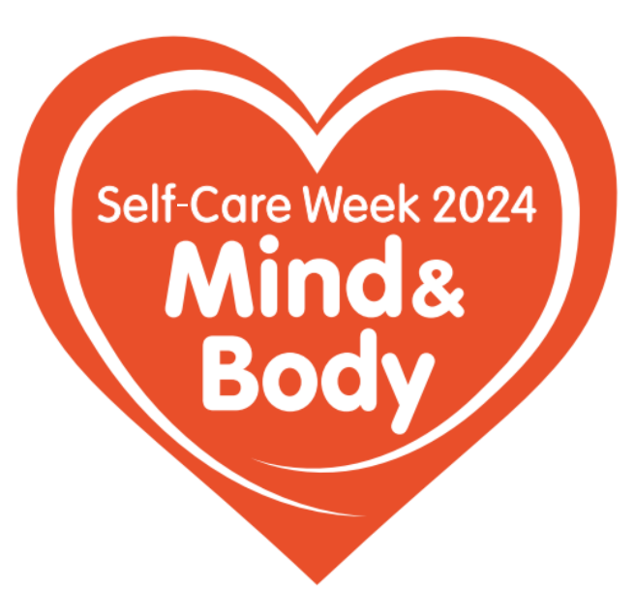

**National Self-Care Week: Prioritising Mind & Body**

**Self-Care Week** is an annual national event dedicated to raising awareness about the importance of self-care for both our physical health and mental wellbeing. This year’s theme, **Mind & Body**, encourages us to take a broad approach to our health.

Organised by the **Self-Care Forum**, a charity committed to empowering individuals to make self-care a daily habit, Self-Care Week is a perfect opportunity to reflect on how we can better care for ourselves and our loved ones.

**Why Self-Care Matters**

Incorporating self-care into our daily routines can significantly enhance our overall health. Research shows that maintaining good health helps us better manage life’s challenges. While self-care is essential every day, Self-Care Week serves as a timely reminder to make small, impactful changes that can improve our wellbeing.

**Simple Changes for a Healthier Life**

Here are some practical ways to incorporate daily self-care into your life:

* **Nutrition**: Pay attention to what you eat and drink. Opt for balanced meals and stay hydrated.
* **Exercise**: Regular physical activity is crucial. Find an exercise routine that you enjoy and can stick to.
* **Sleep**: Ensure you’re getting enough rest. Good sleep is vital for both physical and mental health.
* **Work-Life Balance**: Maintain a healthy balance between work and personal life. Stay connected with friends and family, as social interactions are key to our wellbeing.

**Where to Seek Help**

Self-care is not no care and knowing when and where to go for help is an important part of self-care practise. It’s also not just about visiting your GP; pharmacies are excellent sources of health advice and treatments. Pharmacy teams can also direct you to the relevant services for additional support.

For non-life-threatening health issues, **NHS 111** is a valuable resource and it now has a service for mental health advice.

The [**NHS website**](https://www.nhs.uk/)offers extensive information on how to care for yourself and your family. Additionally, the Self-Care Forum provides useful fact sheets that you can download [here](https://www.selfcareforum.org/fact-sheets/).

**The Bigger Picture**

Remember, practising self-care daily benefits not just ourselves but also our families. It also helps the NHS. By taking proactive steps to maintain our health, we help ensure that our health services are available when we need them most.

**NB**

Please change names and links in accordance with your region or country, for example:

NHS website in Scotland: NHS Direct <https://www.nhsinform.scot/>

NHS website in Wales: NHS 111 Wales <https://www.wales.nhs.uk/>

NHS website in Northern Ireland: <https://www.nidirect.gov.uk/>

NHS111 is England and Wales, alternatives:

NHS24 in Scotland

GP out of hours service in Northern Ireland <https://www.nidirect.gov.uk/articles/gp-out-hours-service>