Self Care Forum Self-Care Award 2024

Award Application Form and Eligibility

The Self Care Forum is inviting applications of good practise in self-care, personalised care, and social prescribing that have made a difference to individuals, groups, or organisations.

Who can apply?
This invitation is open to everyone, whether you are an individual, a community champion, an employer, surgery, council, library, school, college, business, or services organisation (public, private, or charitable). For a guide, see examples table below.

£500 bursary
The winner will receive a £500 bursary to spend on a self-care related initiative and the top entries will be included on the Self Care Forum website to share best self-care practise and excellence. The winners will be announced during the UK’s National Self-Care Week (18 – 24 November) as part of its launch and promotional activity.

Closing date for admissions: 31st July 2024.

Examples of possible initiatives | If specific health-related conditions were targeted, they might include
- 2023’s Self-Care Week activities  - Signposting to services  - Protecting mental health and wellbeing  - Promoting self-care to the shielded population  - Self-care for the elderly or other specific groups  - Self-care introduced by employers  - Local authority population or community initiatives  - Pharmacy initiatives  - Surgery-led initiatives  - Self-care education by schools, universities, or community groups such as Scouts, Guides etc  - Empowering vulnerable groups | - Long-term conditions  - Obesity  - Diabetes  - General health  - Nutrition  - Exercise  - Mental Health  - Self-treatable conditions/minor illness

Please use the form below to tell us about your self-care initiative.
If you are typing directly into the form, do not worry if the box extends beyond the page – it will continue onto the next one.

Title and contact details.
Title of Initiative (please ensure this is a good description of your initiative in no more than 6 words)
Grab a Cuppa - EOS Peer Support for Parent/Carers
Name of Organisation and Region (please state context, i.e. general practice, community care etc)
Eczema Outreach Support- Charity UK Wide
Name of person or team or individual being nominated
EOS Service Team- Family Workers
Contact name
Suzi Holland, CEO / Moira Clark, Service Lead – Nominated by Project Lead Sandra Lawton
Contact email for entry
suzi@eos.org.uk / moira@eos.org.uk
Timeframe and dates of initiative
The initiative commenced in November 2023 with a plan for Bi- monthly sessions initially and after 6 months them to then be monthly
Date of submission
05/06/2024

About your self-care initiative

Describe the problem you were facing and your objective(s) in tackling this. (200 words max)

Eczema Outreach Support (EOS) are unique as they are the only UK charity dedicated to helping children, young people with eczema and their families, offering free practical advice, one-to-one support, organising events, and advocating for the rights of children and young people with eczema, empowering them to take back control of their health, breaking the isolation many experience. Crucially, they recognise the importance of shaping their services based on the experiences of their members and working with health care professionals, educational professionals, and researchers, with their purpose being that:
"Children and young people with eczema know they are not alone”.
Being a parent or carer of a child with eczema can be incredibly challenging at times and their members often tell them that they feel guilty and frustrated, especially when treatments do not seem to be helping or they cannot access the support they need. With the feedback received from parents the family workers identified the need to expand their current services to provide specific support forums for the families and “Grab a Cuppa” came to fruition as a result.

Outline your initiative, explain your planning and execution of the project. (200 words max)

New members receive a welcome pack and are offered one-on-one support from the family workers and for many parents they appreciate the support EOS offers but also wanted the opportunity to meet others experiencing the challenges of caring for their child with eczema. Online events were already in place with the “High Five Club” for Children aged 3-10 and the team developed the online “Grab a Cuppa” events to provide parents and carers the opportunity to come together and share experiences, swap stories, tips and have a chit chat about all thing’s eczema, something they might never have done before. The team were able to implement this easily as they had experience from their other online events and themes for the session were based on the family workers’ conversations with families, on their support calls. Their work has changed lives, parents feel more confident about managing their child’s eczema, as well as simply better able to cope:
“The support, advice, help and direction the amazing team gave us was game changing.”
“I wish I had come across EOS years ago as we have struggled for 12 years.”

What were the challenges and how did you overcome these? (200 words max)

The main challenge was to develop the idea and to implement it in a timely manner with clear objectives for the service team:
• Operations – oversight of the other EOS programmes ensuring they are well designed, appealing and will have a positive impact on their members (reviews and new programmes)
• Communications and Campaigns – spread the word and raise awareness of EOS
• Finance and Resources – contribute to ensuring that they have and continue to have the resources available to make it all happen (including fundraising, researching funding streams and/or supporting funding applications)

Did you collaborate with other local partners, if so, who were they?
No

Would you describe your initiative as “innovative,” if yes please provide details. (100 words max)
Feedback from family support calls clearly showed how isolated they feel with others not understanding eczema and the impact it has on the children and their parents. Nationally there are very few, if any local support groups for families and with the impact lock down had, it became clear that online was the way forward, to ensure the support provided was appropriate and safe for families, as there is so much misinformation regarding eczema on social media sites. Below summaries key words which show why it is innovative:

I | N | N | O | V | A | T | I | V | E
Isolation | Negativity | Needed | Online | Valuable | Appropriate | Timely | Impact | Visibility | Engaging

Impact, outcomes, and evidence
Who was the initiative directed at and what were the benefits to the targeted group or individuals? ( 200 words max)

With a clear purpose the initiative was to develop the EOS “Grab a Cuppa” in order for parent/carers to have the opportunity to meet others, increase their confidence in talking about eczema, sharing experiences and not to feel isolated, which they have achieved.

The Family Workers offer help from the beginning of the family's eczema journey. Providing valuable tips to enhance eczema care so every child can thrive. By growing their community, they can provide greater education around eczema. Allowing families to self-manage their condition in a safe, sustainable way. They measure their success by assessing the practical impact they have on the lives of the parents, children, and young people (YP) managing eczema through three main areas:

• Confidence: parents and their children with eczema will have increased confidence in self-management and coping skills.
• Supported: parents and their children will feel more supported to deal with eczema and the impact is has on their lives.
• Connected: parents and their children will feel more connected with others by having access to a community of peers.

Please quantify the impact of your initiative. (e.g. cost improvement, numbers of people helped, time saved)
Below are the events to date, themes of the sessions and numbers attending:

DATE | TOPIC/CONTEXT OF SESSION |  | NUMBER OF MEMBERS ATTENDED | NUMBER OF ATTENDEES RECURRING
02/11/23 | Eczema and the winter months themes:  Pop the kettle on and pour yourself a cuppa for joining us online for our first peer support.  With the days getting colder, we thought it would be the perfect opportunity for our members to come together and swap stories, tips and have a chit chat about all things eczema and the winter months.  To get the conversation going we will be chatting eczema and winter, but the conversation won’t be limited to this topic. |  | 14 | n/a
14/12/23 | Eczema and the Festivities themes  With the festive season in full swing, we thought it would be the perfect opportunity for our members to come together and have a chit chat about how to navigate the struggles of Christmas with eczema.  Scratchy party dresses, soap gift sets and unhelpful comments can add unwanted stress to Christmas. Pour yourself a cuppa and come join our online peer support to offload and destress. |  | 8 | 3
31/01/24 | Youth Panel Q&A Session with parents:  https://eos.org.uk/youth-panel/ | 11 |  | 2
2/3/24 | Dundee family event- live face to face grab a cuppa | 8
25/04/2024 | Lynne Family Worker introduced the High Five Club to the parents:  https://eos.org.uk/we-can-support-you/high-5-club/  This virtual club is for children aged 3 –10 (currently 2,947) and is co-ordinated by the team of family workers who deliver a variety of activities, resources and videos, information, and virtual meetings. They make sure that each child with eczema knows they are not the only one with itchy skin and see others with the condition through online sessions and resources such as animations and story books. | 11 |  | 4
30/05/2024 | Jean Senior Family Worker introduced the School Support EOS provide:  https://eos.org.uk/we-can-support-you/eczema-at-school/  A school online workshop programme has been developed to educate pupils and teachers about eczema. The programme is structured into age-appropriate lessons where their family worker will discuss what it feels like to have eczema, highlights what can trigger it and where triggers can be found in the classroom. And how the school community can look out and help someone with the condition. They provide resources directly to the school which allows the online delivery to be interactive which includes a moisture meter so pupils can see quantitative data on the effects of using moisturiser on dry skin.  Key Messages from the session were:  How EOS can help: resources, training, education  Help to arrange a later school start time if necessary  Open and clear communication  Meet school staff  Exam considerations | 13 signed up 5 attended |  | 2

Do you have formal or anecdotal evidence of success? (e.g. qualitative, quantitative, informal feedback?)
The team measure their progress a combination of quantitative & qualitative methods. This includes their members’ survey, specific activity evaluations and polls. Monitoring levels of membership and engagement, as well as through direct feedback from our members:
- Great info and tips from parents. Good to hear from everyone.
- Great meeting other parents
- Has been a great chance to share and meet other people in the same boat as my family, such a great service.
- Great to chat to other parents experiencing the same as me - never been able to do this before, helpful to ask others about their experiences.
- It’s lovely to meet other parents who understand and are in the same boat.
- I was on the call this morning - thank you so much, really helpful.
- Thank you for this morning’s cuppa and chat. I wish I knew another parent with a child with eczema close by to where I live as it really does help. Some great advice this morning.
- Thanks for a lovely session! It is so important to meet other parents who go through a similar itchy journey.
- It was lovely to hear from the youth panel about their more recent challenges they have faced with eczema rather than depending on my own from far too many years ago.
- Really useful specific advice and experience (on residentials) and reassurance we're all going through the same thing on an emotional level.
- I'm not feeling like the only one - others going through the same thing.
- It is good to hear other stories of battles with eczema
Their impact is reflected in their survey of members:
• 90% felt more confident following their child’s treatment plan
• 96% felt more supported and understood in relation to their child’s eczema
• 76% felt more confident dealing with their child’s school or nursery about eczema
• 86% felt better able to cope with the impact of eczema on family life
• 99% said they would recommend EOS to a friend

Learning and sustainability
What was the cost of this initiative in time, money, and other resources? Please be as specific as you can

Funding to support this and other activities within EOS comes from a various sources and successful grant applications, with some of these grants allocated for specific areas of work, which was the case for this initiative. Costs include staffing, developing the workshops which include face to face events. As with other charities funding applications are providing a challenge which impacts on future plans and service provision moving forwards.

Were there any learnings from the initiative, if so what were they? (200 words max)

Key area and themes from the support calls clearly identified that the mental health and wellbeing of both the children and their parents was a priority, which resulted prior to this initiative in the development of their wellbeing resources for the children and young people, working with Dr Ella Guest, a Senior Research Fellow and Chartered Psychologist based at the Centre for Appearance Research (CAR) at the University of the West of England (UWE) in Bristol:
https://eos.org.uk/wellbeing-resources-for-children-and-young-people/
The ‘Grab a Cuppa’ sessions have also confirmed and highlighted that there is also a potential need for further work and developments, which as an organisation they are aware of the work being undertaken nationally. In the meantime, they signpost parents to appropriate support from their health care professionals and other mental health charities.

Are you continuing to implement the initiative, please give details. (200 words max)
Following the initial Bi-monthly meetings which have been successful , the plan is to now develop these further holding them monthly and with themes running alongside the ‘High 5 Club’ – For children aged 3-10: https://eos.org.uk/we-can-support-you/high-5-club/ https://eos.org.uk/we-can-support-you/high-5-club/
Plans are also in place to look at hosting live experience sessions at events planned nationally

And, finally…
How easy will it be to replicate your initiative, and do you have top tips to share? (max 200 words)

With so many more families/ young people looking to use social media forums for support and information, this initiative is applicable to many and easily adopted. The key points to consider when doing so include:
- Be flexible with timings throughout the day to allow for various family commitments and plans.
- Assess the risks of using online platforms
- Always have 2 team members on the call
- Set ground rules- not to take photos, screen shots and the importance of confidentiality
- Not to share personal details

Did you use any of the Self Care Forum’s resources? If so, please specify.

No

Please provide the social media addresses of all those who were involved in the initiative.

Eczema Outreach Support (EOS): https://eos.org.uk/

Email: info@eos.org.uk

Why do you think this initiative deserves to win the award? (Max 100 words)
As a team they feel proud that working with the parents they have made a difference to their lives, who are now able to access peer support, advice, have a voice and the confidence to care for their child. The team are flexible, they listen to feedback but what is important to them is that the parents feel safe, secure, accepted and informed, they have made a difference and are proud to say that they have achieved this and continue to do so. Listening to the parents has made a difference and influenced what they do now and in the future.
Do you have an image, materials or weblinks to supplement your application? Please supply no more than 2 images which may also be used to promote your application if successful. Ensure images are square (ie height and width dimensions are the same).

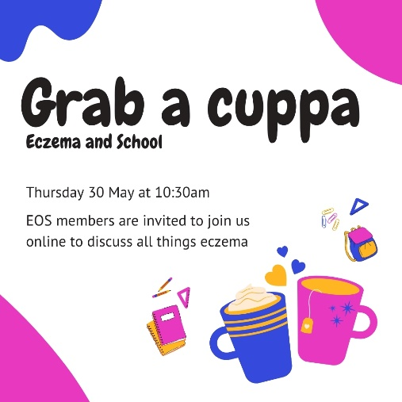
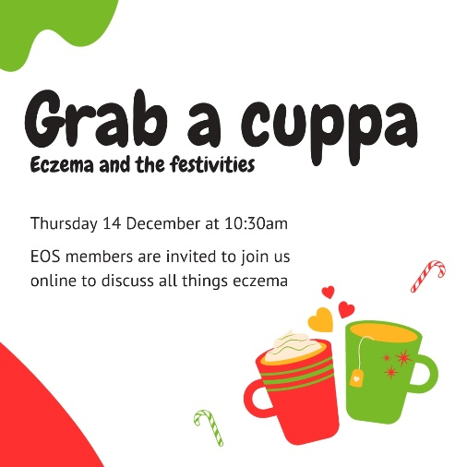

Your application may be chosen to be uploaded to the “best practise” page of the Self Care Forum website to share self-care excellence so that others might use the learnings in your application. We will also include your email address so that people may get in touch with you. If you would prefer that your application and/or email address was NOT chosen, then please make it clear in the box provided below.
For communication : info@eos.org.uk
Thank you for taking the time to apply for the Self-Care Awards. We look forward to receiving your application. Please email your completed form to: selfcare@selfcareforum.org

About the Self Care Forum
The Self Care Forum supports organisations in helping their communities and service users better understand how to self-care. It is the leading independent provider of best practice around self-care and the ‘go-to’ place for top quality resources, current opinion, and self-care interventions in the UK.
It is a charity and aims to improve public health by promoting self-care at national policy level. It creates free resources including self-care fact sheets, runs the UK-wide National Self-Care Week, and supports robust research evidence.

For more information about the Self Care Forum please go to the website. www.selfcareforum.org. Please find and follow us on LinkedIn, X and FB.

