Self Care Forum Self-Care Award 2024
Award Application Form and Eligibility

The Self Care Forum is inviting applications of good practice in self-care, personalised care, and social prescribing that have made a difference to individuals, groups, or organisations.

Who can apply?
This invitation is open to everyone, whether you are an individual, a community champion, an employer, surgery, council, library, school, college, business, or services organisation (public, private, or charitable). For a guide, see examples table below.

£500 bursary
The winner will receive a £500 bursary to spend on a self-care related initiative and the top entries will be included on the Self Care Forum website to share best self-care practice and excellence. The winners will be announced during the UK’s National Self-Care Week (18 – 24 November) as part of its launch and promotional activity.

Closing date for admissions: 31st July 2024.

Examples of possible initiatives | If specific health-related conditions were targeted, they might include
- 2023’s Self-Care Week activities  - Signposting to services  - Protecting mental health and wellbeing  - Promoting self-care to the shielded population  - Self-care for the elderly or other specific groups  - Self-care introduced by employers  - Local authority population or community initiatives  - Pharmacy initiatives  - Surgery-led initiatives  - Self-care education by schools, universities, or community groups such as Scouts, Guides etc.  - Empowering vulnerable groups | - Long-term conditions  - Obesity  - Diabetes  - General health  - Nutrition  - Exercise  - Mental Health  - Self-treatable conditions/minor illness

Please use the form below to tell us about your self-care initiative.
If you are typing directly into the form, do not worry if the box extends beyond the page – it will continue onto the next one.

Title and contact details.
Black Men Talk Health online peer support group
Nilaari Agency: 184 Stapleton Road, Bristol BS5 0NZ.
Community based Mental Health Charity in Bristol, England
Name of person or team or individual being nominated
Mental health Practitioner Michael Earle & Errol Pitter
Contact name for entry: Jean Smith
Contact email for entry: Jean.Smith@nilaari.co.uk
Timeframe and dates of initiative: Ongoing since September 2019.
Date of submission: 10 July 2024

About your self-care initiative
Describe the problem you were facing and your objective(s) in tackling this. (200 words max)

Black men are vulnerable to deteriorating mental health, in part because they do not talk about mental health problems they may have, for fear of seeming weak. This can build to a crisis point when they may struggle with suicidal ideations, or become angry and violent, resulting either in a prison sentence or being sectioned in a locked hospital ward. This is detrimental to themselves, their families, friends and community. It reinforces the stereotype of Black men as angry, aggressive and violent, which in turn causes a negative response from the statutory mental health services which are there to help them.

We’re experiencing a national crisis where Black people form 3% of the British population, but 16% of the prison population (Statista). In 2022, black males were almost five times as likely than their white counterparts to be detained under the Mental Health Act. (UK Government).

Our objective was to create ways to engage and use our cultural experiences of working with Black people to create a supportive and engaging environment that encourages Black men to take an active role in their mental health and well-being.
Outline your initiative, explain your planning and execution of the project. (200 words max)

Nilaari Agency specialises in providing mental health support to the local Black, Asian and ethnic minority communities. Our experience shows that talking therapies can help reduce mental stress and give clients the tools to support themselves.

Given the problems of supporting Black men who do not talk about their mental health, we decided to provide an online safe space where facilitators could help them open up and talk about their mental health in a non-judgmental way.

We also wanted men to be able to access up-to-date information from professionals of similar ethnicities to themselves, on topics related to mental and physical health.

Using internal and external networks, we approached professionals who mostly volunteered their time free of charge.

We began with 1.5-hour sessions held monthly at a regular time with a small number of Black men already known to us.

Each session had a theme and speaker (e.g.: loss and bereavement, managing negative thoughts, prostate cancer, relationships), followed by discussion arising from the theme and branching out from there.

The sessions went well, so we designed a leaflet circulated by hand in local communities. Word quickly spread and our most recent session had 92 participants.

Funds were raised to cover project design, facilitation, and speakers.
What were the challenges and how did you overcome these? (200 words max)

Challenges & solutions included

Encouraging participation: One of the many challenges we had to overcome was how to encourage Black men to come online and talk about their physical and mental health amongst total strangers. As a solution we started by engaging with men known to us and worked hard to build trust through personal interactions and over time extended invitations beyond initial contacts.

Retention: We had to ensure the consistent timing for sessions and would send regular reminders to the men well in advance of each session. We established a predictable schedule (e.g., the last Thursday of the month at 11:30 AM) and maintained clear communication.

Increasing participant numbers: To improve sessions we took time to gather feedback in order to tailor themed sessions to participants' interests. We also encouraged word-of-mouth promotion. As a solution we worked hard to design promotional materials that are visually aligned and culturally appropriate to advertise in local community venues, through local radio, and we engaged with faith groups.

Extending our reach: Setting time aside to prioritise intensive outreach efforts was a necessary challenge. Initially we had to reduce session frequency to once every two months to manage time and resources better.

Did you collaborate with other local partners, if so, who were they?

Local partners that collaborated with us were:

- The Wellspring Settlement (a nearby organisation which enables the local community to actively participate in positive, life-affirming activities)

- Rethink Mental Illness, a national body with local agencies that work to improve the lives of everyone severely affected by mental illness

- A number of churches locally

- Two local mosques and a number of the local barber shops near to our offices
Would you describe your initiative as “innovative,” if yes please provide details. (100 words max)
The online initiative helped:
Reduces isolation: The safe space enabled Black men to discuss their mental health, the initiative significantly reduced feelings of loneliness and paranoia exacerbated by the pandemic.
Builds trust: By creating a trusted space where men feel comfortable enough to openly discuss issues important to them, thus increasing engagement with mental health services.
Provides holistic support: By providing not only mental health support but also fostering a sense of community and belonging among participants.
Create a scalable model: This successful model could be replicated or expanded to other marginalized groups or locations.

Impact, outcomes, and evidence
Who was the initiative directed at and what were the benefits to the targeted group or individuals? (200 words max)

This initiative is a pioneering step towards addressing mental health disparities within the Black communities in Bristol. By focusing on a specific and previously underserved demographic, we not only provide much-needed support but also set a precedent for future mental health interventions in the community.

Black men who find it difficult to talk about their mental and physical health challenges, leading to a deterioration of their mental health till breaking point is reached.

Gathering a group of Black men aged between 45-75 years to talk about mental health is groundbreaking especially considering that none of the men had previously engaged in any mental health support services. This approach is innovative and significant for several reasons:
- We have created a safe and supportive environment for open discussions that helps to break down several barriers.
- Breaking mental health stigma can be particularly strong in certain communities, including older Black men.
- Building Trust with Black men who have never accessed therapeutic support i.e. counselling services, the Black Men Talk initiative has helped to build trust and familiarity with mental health services, making future engagement more likely.
- Positive feedback and the growing numbers of participants testify to the benefits.

Please quantify the impact of your initiative. (e.g. cost improvement, numbers of people helped, time saved)

Quantified Impact of the "Black Men Talk" Initiative
Participation Growth:
  - Initial session (September 2019): 11 participants
  - Most Recent Meeting (June 2024): 92 participants
  - Growth Rate: Over 700% increase in participation over four years
The total number of males over the past four years that have attended regular sessions equates to over five hundred that have been directly supported. By addressing critical issues such as loneliness and social isolation a significant portion of the men have reported a significant improvement in their mental health outcomes.
Do you have formal or anecdotal evidence of success? (e.g. qualitative, quantitative, informal feedback?)
Participant Feedback
Positive messages and calls: Numerous calls and messages from the men expressing their appreciation for the safe online space created by the workshops.
Support for Continuation: Strong support from the participants to continue the online sessions, highlight the lack of similar spaces for men of colour to discuss physical and mental health matters.
Behavioral Changes and Health Outcomes:
Increased engagement with healthcare: the men have and continue to report they are now more likely to reach out for physical health checks with their GP, indicating a positive shift towards proactive health management.
Higher demand for talking therapies: we have seen an increase in requests from Black men to access talking therapies, therefore showcasing the initiative's role in reducing stigma and encouraging men to access mental health support.

Learning and sustainability
What was the cost of this initiative in time, money, and other resources? Please be as specific as you can

Total Estimated Annual Cost
- Designing of Initiative (including promotion material): £1,500 (one-time cost)
- Facilitation & admin support: £1,600
- Outreach: £1,500
- Speakers: £2,000
- Volunteers expenses: £300
- Total: £6,900 for the first year (including design costs)

Were there any learnings from the initiative, if so what were they? (200 words max)

The major learning from the initiative is that Black Men do want to discuss their mental & physical health concerns if they are given a dedicated space/platform that they see as safe and non-judgmental.

Cultural relevance of the topic and speaker was important in creating a space that seemed comfortable to participants.

Consistency of both time and format was important in retention.

It took a much larger amount of time than we had expected to carry out the outreach needed to extend the numbers of men.
Are you continuing to implement the initiative, please give details. (200 words max)

It is our aim to continue our online sessions, as well as expand our offering by starting quarterly in-person sessions. This will bring men together to listen, learn and support one another with hands-on practical skills. Having a physical presence may also increase our reach with younger men.

Feedback will be encouraged and used to continuously adjust and improve the content and delivery. And to identify future topics/themes (plus speakers) identified by the men.

By implementing these strategies, we will continue to build on the work started by creating a supportive and engaging environment that encourages Black men to take an active role in their mental health and well-being.

And finally…
How easy will it be to replicate your initiative, and do you have top tips to share? (max 200 words)

Gathering a specific group of Black men aged between 45-75 years to talk about mental health is a groundbreaking initiative, especially considering that none of the participants had previously engaged in mental health services.

This initiative could be easy to replicate by organisations who already have contacts in local Black communities.

Top tips includes:

- At the planning stage, include sufficient time for advertising/promoting the initiative and spreading the word.
- Ensure promotional materials are visually culturally sensitive and appropriate
- Keep to the same length of time for each meeting e.g. one and a half hours.
- Keep to the same date, e.g.: the last Thursday of the month.
- Keep the format the same, with a guest speaker to present the given topic, then open up for questions and discussion after.
- It is important to have culturally appropriate facilitators and speakers.
- Support & advice available to men outside of sessions
- Setting aside time to prioritize time intensive outreach efforts
Did you use any of the Self Care Forum’s resources? If so, please specify.

We did not use any of the Self Care Forum resources.

Please provide the social media addresses of all those who were involved in the initiative.
Wellspring Settlement: https://wellspringsettlement.org.uk
- The Wellspring Settlement: This nearby organisation plays a crucial role in empowering the local community to engage in positive, life-affirming activities. Their focus on community participation complements Black Men Talk Health’s mission by promoting social well-being and active engagement.
- Rethink Mental Illness: As a national body with local agencies, Rethink Mental Illness works to improve the lives of those severely affected by mental illness. Their expertise and resources enhanced our reach.
- Barber Shops: Involvement of local barber shops adds a unique and culturally significant element to the support network. Barber shops often serve as community hubs where individuals feel comfortable and connected, making them an ideal setting for outreach and engagement.
- Small Black-led Voluntary Organisation: These organisations helped bring even more valuable insights and culturally relevant support to the project. Their grassroots connections and understanding of the specific challenges faced by the black community are crucial for delivering effective and empathetic services.

We are promoting self-help mental health for vulnerable people in the community. Clearly word of mouth has contributed to fast growing numbers. The cost is low, and the initiative is easy to replicate. One of the other positive reasons we should win is that we have created not just a locally accessible forum but a global one as we had participants from overseas participating in the workshops.
Do you have an image, materials or weblinks to supplement your application? Please supply no more than 2 images which may also be used to promote your application if successful. Ensure images are square (i.e. height and width dimensions are the same).

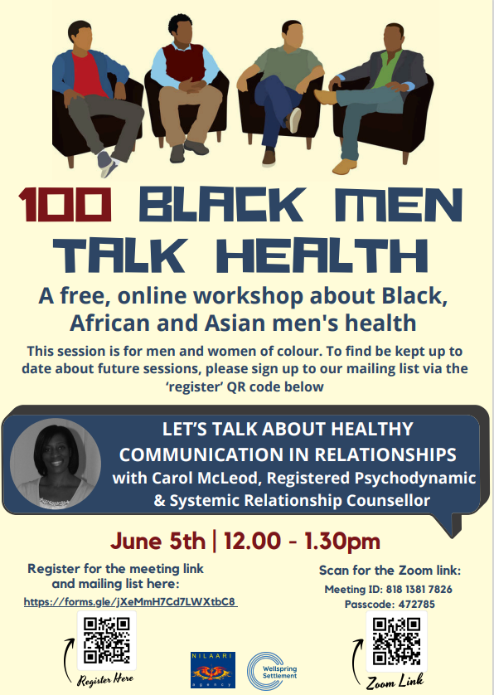
Your application may be chosen to be uploaded to the “best practice” page of the Self Care Forum website to share self-care excellence so that others might use the learnings in your application. We will also include your email address so that people may get in touch with you. If you would prefer that your application and/or email address was NOT chosen, then please make it clear in the box provided below.

We are happy for our email address to be visual.

Thank you for taking the time to apply for the Self-Care Awards. We look forward to receiving your application. Please email your completed form to: selfcare@selfcareforum.org

About the Self Care Forum
The Self Care Forum supports organisations in helping their communities and service users better understand how to self-care. It is the leading independent provider of best practice around self-care and the ‘go-to’ place for top quality resources, current opinion, and self-care interventions in the UK.
It is a charity and aims to improve public health by promoting self-care at national policy level. It creates free resources including self-care fact sheets, runs the UK-wide National Self-Care Week, and supports robust research evidence.

For more information about the Self Care Forum please go to the website. www.selfcareforum.org. Please find and follow us on LinkedIn, X and FB.

