Self Care Forum Self-Care Award 2024

Award Application Form and Eligibility

The Self Care Forum is inviting applications of good practise in self-care, personalised care, and social prescribing that have made a difference to individuals, groups, or organisations.

Who can apply?
This invitation is open to everyone, whether you are an individual, a community champion, an employer, surgery, council, library, school, college, business, or services organisation (public, private, or charitable). For a guide, see examples table below.

£500 bursary
The winner will receive a £500 bursary to spend on a self-care related initiative and the top entries will be included on the Self Care Forum website to share best self-care practise and excellence. The winners will be announced during the UK’s National Self-Care Week (18 – 24 November) as part of its launch and promotional activity.

Closing date for admissions: 31st July 2024.

Examples of possible initiatives | If specific health-related conditions were targeted, they might include
- 2023’s Self-Care Week activities  - Signposting to services  - Protecting mental health and wellbeing  - Promoting self-care to the shielded population  - Self-care for the elderly or other specific groups  - Self-care introduced by employers  - Local authority population or community initiatives  - Pharmacy initiatives  - Surgery-led initiatives  - Self-care education by schools, universities, or community groups such as Scouts, Guides etc  - Empowering vulnerable groups | - Long-term conditions  - Obesity  - Diabetes  - General health  - Nutrition  - Exercise  - Mental Health  - Self-treatable conditions/minor illness

Please use the form below to tell us about your self-care initiative.
If you are typing directly into the form, do not worry if the box extends beyond the page – it will continue onto the next one.

Title and contact details.
Title of Initiative (please ensure this is a good description of your initiative in no more than 6 words)
Living Mindfully Patient Group
Name of Organisation and Region (please state context, ie general practice, community care etc)
Central Bournemouth Primary Care Network
Name of person or team or individual being nominated
Elle Gray – Self Management Team
Contact name for entry
Elle Gray
Contact email for entry
elle.gray@dorsetgp.nhs.uk
Timeframe and dates of initiative
December 2023 - Present
Date of submission
20/07/24

About your self-care initiative
Describe the problem you were facing and your objective(s) in tackling this. (200 words max)

As a social prescriber, I had multiple patients (predominantly women) whom I was supporting individually with mental health coping skills, reframing, and empowering. The mental health services in the area are all under massive strain with long wait lists. I was frequently going over the same things with these patients, I thought it would make sense to do this in a group setting. It also means that those individuals could make connections with one another, who have faced similar situations and/or suffer with related conditions to facilitate peer support from others with shared lived experiences. We found that in our other groups we held, the patients connecting with one another encouraged them to be more independent as well as making new connections. Many of these patients were feeling isolated, some even suffering with agoraphobia, so meeting in a group setting provided a goal for them to overcome.

Outline your initiative, explain your planning and execution of the project. (200 words max)

There was an existing group led by a patient volunteer, I supported and facilitated this. This group was aimed at suffers of Fibromyalgia and Long Covid. This group ran for 6 months, but we found there was low attendance, with only 2 patients returning each week. The volunteer then became unwell and was unable to continue. From here, I took over the group and made some changes to increase attendance and the impact of this group on the community. I had a number of patients who I had worked with, and for research, I discussed ideas with them to discover what they would find useful in this group. I concluded that a mindfulness approach would allow me to cover what was needed ie: coping skills, breathwork, grounding, taking notice and gratitude. I arranged logistics and marketing and asked my colleagues to identify any patients who they felt would be suitable. We then invited these patients, along with others who we identified via Systm1 coding, via SMS to the group. I made a 6-month plan of topics to cover and researched different ways of learning, effective mindfulness activities and information to provide information sheets for those attending.
What were the challenges and how did you overcome these? (200 words max)

The challenges that faced the group before I took over were lack of attendance. As it was aimed at a specific group, I made the decision to open it up to any of our patients. We use a meeting room at one of our practices and whilst not a clinical examination room, it did still feel like a clinical space which was something I wanted to soften. To remedy this I purchased light projectors, lamps and electric candles. I used essential oils and arranged the seats in a circle. By doing this it transformed the room and created a welcoming, safe space.

When arranging the topics to cover, I faced difficulty in deciding how to introduce mindfulness to a group who all had different experiences with mindfulness – some may have no experience, and some had practiced it often. I aimed to ensure the group and content was accessible to anyone, regardless of their existing knowledge.

Another challenge I faced was managing the time, as often in discussions one patient may talk for a lengthy time, resulting in not everyone was able to share. To overcome this, I decided to implement a variation of ‘the talking stick’. This was then passed around allowing everyone their time to share if they chose to.

Did you collaborate with other local partners, if so, who were they?

In my research prior to commencing the group, I used information from ‘Mind’ and other mental health charities.

In one session of the group, we held a ‘Sound Gong Bath’, this was performed by a colleague at Dorset Mind (although her Sound Baths are done privately)

I also have plans to work with a local service ‘Parks in Mind’ to hold an outside seated yoga session.

Would you describe your initiative as “innovative,” if yes please provide details. (100 words max)

In the context of working for a PCN, I believe holding this group is innovative as no others in the area provide this service. It is a holistic way of supporting multiple patients at once to empower, support and improve their wellbeing. I also am regularly researching different approaches and types of activities to explain the topic at hand. I have researched different learning styles, to ensure everyone’s needs were met.

Impact, outcomes, and evidence
Who was the initiative directed at and what were the benefits to the targeted group or individuals? (200 words max)

The initiative was directed at those in our PCN who suffered with low-medium level mental health, as well as patients who had been diagnosed with Fibromyalgia and Long Covid.

There are limited low-cost resources in our local area to support these individuals, and many that do have a long waiting list. Subsequently, those who required support were not able to access the services they needed in a timely manner.

I have found that due to many of the patients having similar experiences, they benefit from discussions with one another. There have been connections made in the group that have carried on outside, meaning these patients have made connections with others which were a goal in their wellbeing journey.

This patient group also faced a barrier of attending groups due to anxiety. I explained to patients that I will be there to meet them outside, and that all the other participants feel that same anxiety.

The group has become a supportive, safe place for patients to take some time for themselves.

Please quantify the impact of your initiative. (e.g. cost improvement, numbers of people helped, time saved)

Over the 5 months there has been a total of 25 patient who have attended the group
10 of these are now attending regularly and report a positive impact on their wellbeing and they have learnt tools to help them get through day-to-day.

If I were to have met each of these 10 patients 1:1 each month that would be 10 hours a month, therefore that time has been saved. At my social prescriber hourly rate of £15.67, that is a cost saving of £156.70 monthly.

As well as this, the group can lead to less GP appointments, in particular ones regarding their mental health.. The Kings Fund suggests that a face to face GP appointment costs £56* so there are further savings here on avoiding unnecessary appointments. *Source: https://www.kingsfund.org.uk/insight-and-analysis/data-and-charts/key-facts-figures-nhs

Do you have formal or anecdotal evidence of success? (e.g. qualitative, quantitative, informal feedback?)

Feedback from group – all positive and main point was that they would like it more frequently.
Increased numbers of attendees
Increased number of attendees coming back to each session

As well as this, I have had reports from attendees that they have implemented what they have learnt which has helped them get through tough times such as, being in hospital, losing a loved one and to help through days of high pain.

One patient is currently having to make a decision about stoma bag surgery, at the group she met another patient who had had the surgery, and they met up to discuss and help the patient get the information needed to make a decision.

One of the patients is a full time carer for her elderly husband, and told me that the group is the only time she has to take a break and spend time on herself. After 5 groups she has now told me that she has begun scheduling in an hour a day to take time for herself so she can better take care of her husband, and herself.

A number of the patients have met up and attended a local sound gong bath together and are now planning to go to weekly yoga together.

Two patients are now volunteering with the group, by helping make hot drinks, and help others with the tasks when needed. These patients were previously anxious and unable to leave the house. They have told me that the group has helped them gain confidence and boost their self-esteem.

Learning and sustainability
What was the cost of this initiative in time, money, and other resources? Please be as specific as you can

Initial Planning hours – approx. 10 hours over 2 months of work time, as well as private time spent researching.

Monthly planning – 3-5 hours a month

Monthly group – 3 hours overtime (as is an evening group)

Money – for one session, we created sensory boxes. For this I spent £60 on materials for this

Were there any learnings from the initiative, if so what were they? (200 words max)

As we hold a number of other groups at the PCN, many of the teething that come with running a group had already been learnt. I did learn how to manage time and ensure everyone is able to gain from the group by allowing everyone time to share and discuss. I also found that the following workday I needed to schedule lighter work as the group could become heavy and emotionally draining for me. This is a personal learning, but feel it is important.

Are you continuing to implement the initiative, please give details. (200 words max)

Yes, we plan to continue the initiative, and I am looking at providing 2 a month, one for in the day so those who cannot come in the evening have a chance to attend.

And, finally…
How easy will it be to replicate your initiative and do you have top tips to share? (max 200 words)

I think it would be easy to replicate the initiative.
Tips would be to outline topics for 6 months in advanced, so that the 6 sessions work as a journey for the patient. It also is time saving, and the continuity of the sessions work well.

Did you use any of the Self Care Forum’s resources? If so, please specify.

Unfortunately not as I was not aware of the resources, however I plan to use these to help me plan in the future, as well as to help creating information/work sheets for each session.

Please provide the social media addresses of all those who were involved in the initiative.

Ellë Gray | LinkedIn
Facebook – Central Bournemouth PCN Facebook Page

Why do you think this initiative deserves to win the award? (Max 100 words)

I have seen first hand the positive impact that this group has had on the attendees. From their feedback, I know that; from learning breathing exercises, they have used this during difficult times, the sensory boxes have helped them ground themselves and learn self care, the meditations have provided them time to take for themselves. The connections that have been made so far at the group means the impact continues outside of the initiative. I believe this group deserves to win this award as I hope we can continue to support patients learn ways to help themselves, and even teach others by passing on what they have learnt.

Do you have an image, materials or weblinks to supplement your application? Please supply no more than 2 images which may also be used to promote your application if successful. Ensure images are square (ie height and width dimensions are the same).

Consent to share photos in application given, further consented will be required to share these photos outside of our organisation.

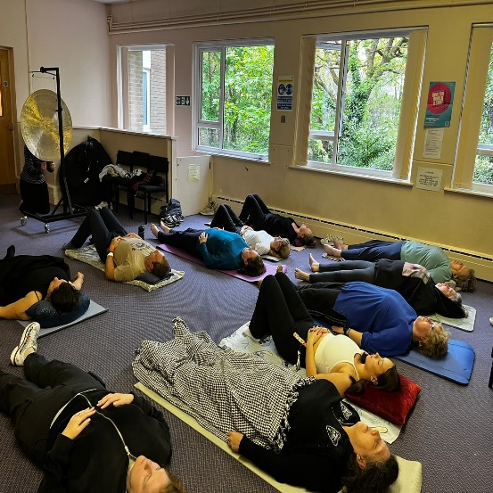

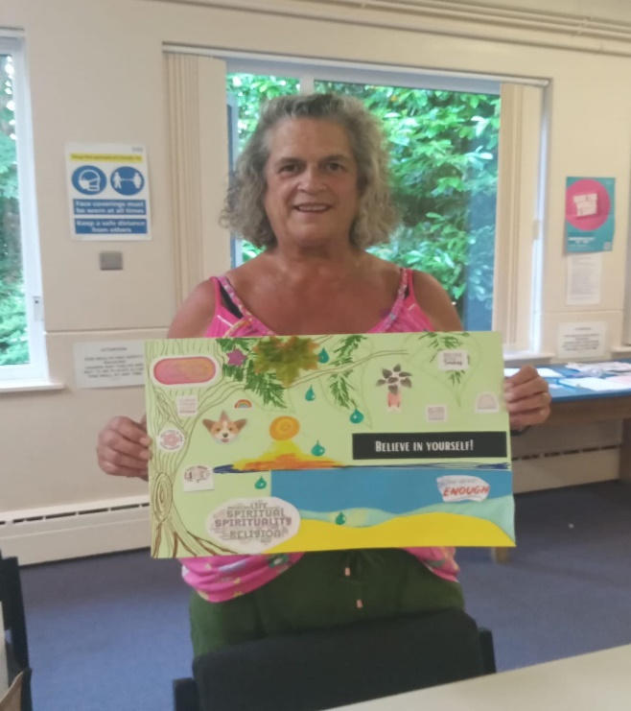

Your application may be chosen to be uploaded to the “best practise” page of the Self Care Forum website to share self-care excellence so that others might use the learnings in your application. We will also include your email address so that people may get in touch with you. If you would prefer that your application and/or email address was NOT chosen, then please make it clear in the box provided below.
I am happy for the above information to be shared.
Thank you for taking the time to apply for the Self-Care Awards. We look forward to receiving your application. Please email your completed form to: selfcare@selfcareforum.org

About the Self Care Forum
The Self Care Forum supports organisations in helping their communities and service users better understand how to self-care. It is the leading independent provider of best practice around self-care and the ‘go-to’ place for top quality resources, current opinion, and self-care interventions in the UK.
It is a charity and aims to improve public health by promoting self-care at national policy level. It creates free resources including self-care fact sheets, runs the UK-wide National Self-Care Week, and supports robust research evidence.

For more information about the Self Care Forum please go to the website. www.selfcareforum.org. Please find and follow us on LinkedIn, X and FB.

