Self Care Forum Self-Care Award 2024

Award Application Form and Eligibility

The Self Care Forum is inviting applications of good practise in self-care, personalised care, and social prescribing that have made a difference to individuals, groups, or organisations.

Who can apply?
This invitation is open to everyone, whether you are an individual, a community champion, an employer, surgery, council, library, school, college, business, or services organisation (public, private, or charitable). For a guide, see examples table below.

£500 bursary
The winner will receive a £500 bursary to spend on a self-care related initiative and the top entries will be included on the Self Care Forum website to share best self-care practise and excellence. The winners will be announced during the UK’s National Self-Care Week (18 – 24 November) as part of its launch and promotional activity.

Closing date for admissions: 31st July 2024.

Examples of possible initiatives | If specific health-related conditions were targeted, they might include
- 2023’s Self-Care Week activities  - Signposting to services  - Protecting mental health and wellbeing  - Promoting self-care to the shielded population  - Self-care for the elderly or other specific groups  - Self-care introduced by employers  - Local authority population or community initiatives  - Pharmacy initiatives  - Surgery-led initiatives  - Self-care education by schools, universities, or community groups such as Scouts, Guides etc  - Empowering vulnerable groups | - Long-term conditions  - Obesity  - Diabetes  - General health  - Nutrition  - Exercise  - Mental Health  - Self-treatable conditions/minor illness

Please use the form below to tell us about your self-care initiative.
If you are typing directly into the form, do not worry if the box extends beyond the page – it will continue onto the next one.

Title and contact details

.

Title of Initiative (please ensure this is a good description of our initiative in no more than 6 words)
Menopause (advocacy, awareness, education, support)
Name of Organisation and Region (please state context. ie general practice, community care etc)
Action Menopause Warwickshire. Community care initiative supporting women to live their lives well through the menopause by the provision of peer support groups.

Name of person or team or individual being nominated
Action Menopause Warwickshire Trustees – Sue Thomas, Helen Cartwright, Liz Clark, Trisha Quinn, Sue Harris, Susie Weston
Contact name for entry
Sue Thomas
Contact email for entry
susan.thomas72@nhs.net
Timeframe and dates of initiative
Focus Group held in May 2022. On going provision of peer support groups identified as a priority..
Date of submission
31 July 2024

About your self-care initiative
Describe the problem you were facing and your objective(s) in tackling this. (200 words max)

Many women are suffering often debilitating symptoms during perimenopause and menopause and currently there are not enough skilled clinicians in primary care with the knowledge about the menopause and confidence in providing medication to provide the help that they need. Our founder experienced a surgical menopause and, despite working in primary care herself, was unable to obtain the support she needed from either primary or secondary care clinicians. She therefore undertook training to equip herself to support her own needs and to become the ‘go to nurse’ to provide a menopause service to the women in the general practice where she works.

She then went on to establish our organisation to support women in the wider Warwickshire community.

Our objectives are to provide practical support, advice and education to help women understand the impact of the perimenopause and menopause on their bodies and to introduce them to methods of self-care that can help them live well throughout this time.
Outline your initiative, explain your planning and execution of the project. (200 words max)

We held a Focus Group to identify the needs of local perimenopausal and menopausal women and to identify the support they would like and how this could best be provided in the community. As a result of this, our main initiative has been to establish regular peer support group meetings where women get the opportunity to meet up, share their experiences with each other and to ask questions to our clinical team, a combination of doctors and nurses who specialise in the menopause. We provide a supportive environment where women can ask questions of a very personal nature by writing them down, meaning they don’t have to voice them in the room. Our clinical team read out each question and answer, so everyone gets the benefit of the information.

Each meeting also has a guest presenter who is an expert in their field and provides information to help women find ways of minimising their symptoms. Examples include a nutritionist, a pelvic health expert, and a specialist in exercise for women over 50. We also cover complementary therapies including reflexology, yoga, mindfulness, as well as general health and wellbeing.

Attendance at these meetings is free of charge.
What were the challenges and how did you overcome these? (200 words max)

We knew of no groups offering what the women at the Focus Group were asking for. We developed from scratch our current model of delivering support, using the diverse skills of our Committee and using our first meeting as a pilot.

A challenge was how to promote the group. We took a stall at the Leamington Spa Ecofest event and many women signed up to receive further contact about our events. We also use Facebook, Instagram and our website landing page. Word of mouth is extremely fruitful with many women bringing friends with them to meetings. We have more than 250 women on our database.

Another challenge was finding a venue that would meet the needs of the group – easily accessible, enough space to run interactive sessions and with free parking. We currently use a working men’s club located between Leamington Spa and Warwick.

Funding has been another challenge and initially the Committee covered all expenses themselves. Funds raised by local supporters now contribute to the overall running of the charity and cover the costs of the support group sessions. We are in the process of making grant applications to local grant giving bodies and the National Lottery to enable us to expand the help that we offer.

Did you collaborate with other local partners, if so, who were they?

We have collaborated with Healthwatch Warwickshire and they attend all of our peer group sessions.

Local businessmen and women

We also collaborate with Lifeways in Stratford-upon-Avon and have contributed to a County Council Task and Finish Group looking at the provision of menopause support within the County.

Dr Louise Newson, an international expert on the menopause from Newson Health, a private menopause clinic in Stratford-upon-Avon, gave a talk to our group which was attended by over 70 local women. Other collaborators are the complementary therapy experts who are our guest presenters.

Would you describe your initiative as “innovative,” if yes please provide details. (100 words max)

Yes, there was nothing like this available previously. We listened to and took advice from menopausal women in our local community to validate our belief that there was a need for self-care support and to identify how they would like to receive. this. Our focus group identified a peer support group as a priority – the women who attended said being in a room with others going through similar things and sharing experiences was invaluable. They also wanted access to healthcare and alternative therapy professionals who could advise on self-care solutions that help with menopause symptoms.

Impact, outcomes, and evidence
Who was the initiative directed at and what were the benefits to the targeted group or individuals? (200 words max)

The initiative is aimed at perimenopausal and menopausal women in our community, particularly those who are experiencing a difficult menopause. By helping women to undertake and implement self-care we believe that we are helping them to live healthier and more fulfilling lives. These benefits also spread to the wider community. Although our focus is the menopause our meetings cover a wide range of health and wellbeing opportunities of benefit to women. Our attendees greatly enjoy the opportunity to participate in interactive sessions and to understand the benefits that activities can have on their health. This was particularly true of the dance workshop that we ran. Reflexology and yoga have also provided great interactive
opportunities.
Our meetings also provide the opportunity for women to understand that they are not alone in what they are going through and to make new friends. It gives them time to focus on themselves and their health, something many say that don’t usually have the opportunity to do.

Please quantify the impact of your initiative. (e.g. cost improvement, numbers of people helped, time saved)

Over 200 women have attended our peer support meetings. By providing expert advice we have no doubt saved many visits to primary care but unfortunately this cannot be quantified. From feedback received we have also supported improvements in mental health. Many women had felt isolated as a result of their symptoms and tell us what a relief it is to know that they are not alone in what they are going through.

Do you have formal or anecdotal evidence of success? (e.g. qualitative, quantitative, informal feedback?)

Comments forwarded to us by email following meetings.

“Thank you so very much for last night, I am still “full” of it and my mind is going into overdrive talking about it to my partner, he said for the first time in ages he can see a difference in me, I said it was great being amongst people who get it, who understand, who know. I don’t know where to begin to thank you, those 2 hours have made an enormous difference to me and for the FIRST time in an extremely long time, I have woken up feeling the most positive I have for a very very long time. My head is in a whirl wind of what I want to do, what I want to achieve, and I want to start it all NOW.”
“I wanted to provide some feedback about the recent menopause talk. I was a bit sceptical about coming and, dare I say it, I thought it might be a bit boring! However I was very pleasantly surprised as I found it really engaging and informative. Thank you for putting it together so well.
The physio talk using the pelvis model was really interesting and she kept us all very engaged throughout and was so knowledgeable and enthusiastic about her subject!
The idea of questions and answers done in the way you did worked really well, I thought, as it mostly remained confidential, in case people were concerned. The answers given were very in depth and helpful.”
“Thank you so much for last night’s meeting. It was my first one and I really appreciated connecting with others for support. The presenter’s session was fabulous.”

Learning and sustainability
What was the cost of this initiative in time, money, and other resources? Please be as specific as you can

Time of the committee is the biggest cost for us. We estimate that it takes an estimated 24 person hours to plan and run each meeting. Per meeting this includes 1 guest presenter, 2 clinical team members, on average 4 Committee members and the time taken for preparation and follow-up. We have so far delivered 12 meetings, so this equates to a total of approximately 288 person hours. All of these hours are provided by volunteers.

We have deliberately kept costs as low as possible, securing a free meeting space for committee meetings and asking event speakers and clinicians to give their time at our peer support group meetings for free.

We pay £40.00 for room hire for each meeting which totals £480.00

We make samples and leaflets available to attendees which have all been provided to us free of charge.

Were there any learnings from the initiative, if so, what were they? (200 words max)

Our Focus group identified over 50 different symptoms that women can experience during the perimenopause and menopause, many of which are not recognised by many health care professionals. Just sharing this information and knowing they were not alone was a great comfort to our women.

We also learnt how little provision there is within the county for perimenopausal and menopausal women and that women have vastly different experiences when seeking help from primary care providers. Our successful group meetings show how keen women are to learn more about the issues they are dealing with and that they want to empower themselves through self-care to feel better or have more control in order to live well throughout this often difficult time.

We shared the results of our findings with the Local Authority and local NHS.

Are you continuing to implement the initiative, please give details. (200 words max

Yes, we intend to continue the peer support meetings. We listen to what women tell us and we hear that many of them would like more support from the men in their lives. Men tell us they would like to help but don’t know how. We are currently working with Healthwatch Warwickshire on a new initiative to ask women what type of support they would like from men, and we aim to hold a Focus Group for men to find out what they would like to know, how they would like to provide support and how they would like to receive this information.

Going forward we have ideas for other new initiatives building on the knowledge and experience gained from our peer support groups.

And, finally…
How easy will it be to replicate your initiative and do you have top tips to share? (max 200 words)

It is easy to replicate this initiative. We have invited a representative from a charity in a neighbouring town to attend our meetings and have also given a talk at an open meeting they held to share what we do. We have also shared the model with an NHS group.

Top tips are to be open to collaboration with other charities and organisations and to engage with others in the local community. Local businessmen and women have been extremely helpful to us by giving time and advice and, on one occasion, use of a venue free of charge.

Did you use any of the Self Care Forum’s resources? If so, please specify.

No. We were not previously aware of these.
Please provide the social media addresses of all those who were involved in the initiative.

Facebook: Action Menopause Warwickshire Facebook.com
Instagram: action_menopause_warwickshire
Website: www.actionmenopausewarwickshire.org.uk

Why do you think this initiative deserves to win the award? (Max 100 words)

There’s a lack of understanding of the impact that perimenopause and menopause can have on a woman’s life and of those around her. It is a natural process that every woman experiences. Some sail through with minimal problems. But for a very large number, it can be life changing. Relationships break down, women leave their jobs due to debilitating symptoms, become isolated at home and, in extreme cases, end their lives by suicide. Our initiative helps prevent these issues from occurring by empowering women with the knowledge of the self-care they can undertake to help themselves, and it’s having a really positive impact.

Do you have an image, materials or weblinks to supplement your application? Please supply no more than 2 images which may also be used to promote your application if successful. Ensure images are square (ie height and width dimensions are the same).
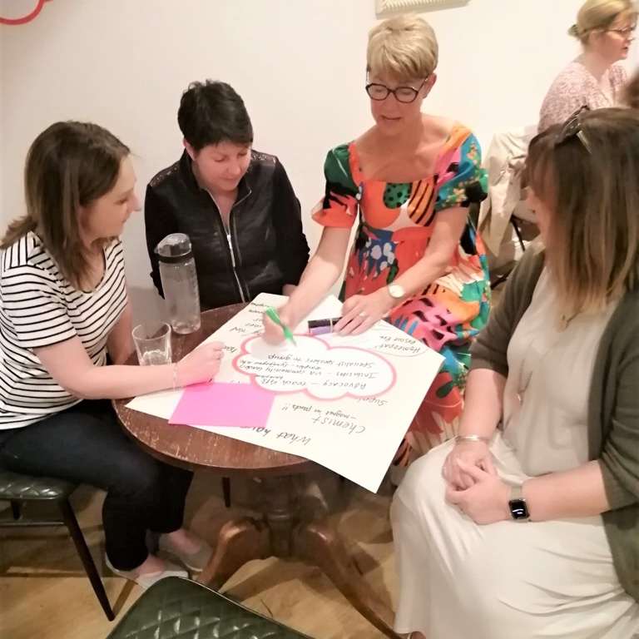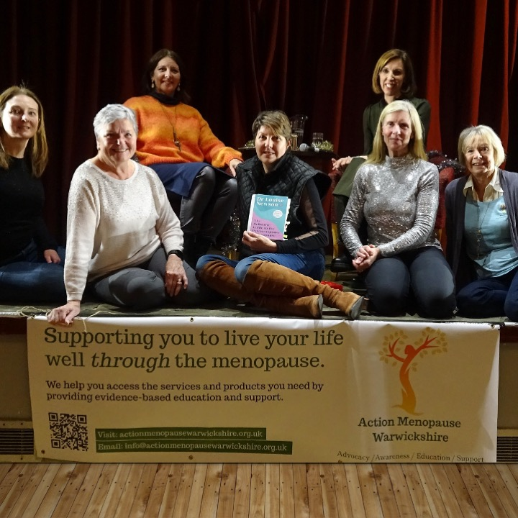
Focus Group Meeting An evening with Louise Newson

Your application may be chosen to be uploaded to the “best practise” page of the Self Care Forum website to share self-care excellence so that others might use the learnings in your application. We will also include your email address so that people may get in touch with you. If you would prefer that your application and/or email address was NOT chosen, then please make it clear in the box provided below.
Thank you for taking the time to apply for the Self-Care Awards. We look forward to receiving your application. Please email your completed form to: selfcare@selfcareforum.org

About the Self Care Forum
The Self Care Forum supports organisations in helping their communities and service users better understand how to self-care. It is the leading independent provider of best practice around self-care and the ‘go-to’ place for top quality resources, current opinion, and self-care interventions in the UK.
It is a charity and aims to improve public health by promoting self-care at national policy level. It creates free resources including self-care fact sheets, runs the UK-wide National Self-Care Week, and supports robust research evidence.

For more information about the Self Care Forum please go to the website. www.selfcareforum.org. Please find and follow us on LinkedIn, X and FB.

