Self-Care Forum Self-Care Award 2024

Award Application Form and Eligibility

The Self-Care Forum is inviting applications of good practise in self-care, personalised care, and social prescribing that have made a difference to individuals, groups, or organisations.

Who can apply?
This invitation is open to everyone, whether you are an individual, a community champion, an employer, surgery, council, library, school, college, business, or services organisation (public, private, or charitable). For a guide, see examples table below.

£500 bursary
The winner will receive a £500 bursary to spend on a self-care related initiative and the top entries will be included on the Self Care Forum website to share best self-care practise and excellence. The winners will be announced during the UK’s National Self-Care Week (18 – 24 November) as part of its launch and promotional activity.

Closing date for admissions: 31st July 2024.

Examples of possible initiatives | If specific health-related conditions were targeted, they might include
- 2023’s Self-Care Week activities  - Signposting to services  - Protecting mental health and wellbeing  - Promoting self-care to the shielded population  - Self-care for the elderly or other specific groups  - Self-care introduced by employers  - Local authority population or community initiatives  - Pharmacy initiatives  - Surgery-led initiatives  - Self-care education by schools, universities, or community groups such as Scouts, Guides etc  - Empowering vulnerable groups | - Long-term conditions  - Obesity  - Diabetes  - General health  - Nutrition  - Exercise  - Mental Health  - Self-treatable conditions/minor illness

Please use the form below to tell us about your self-care initiative.
If you are typing directly into the form, do not worry if the box extends beyond the page – it will continue onto the next one.

Title and contact details.
Title of Initiative (please ensure this is a good description of your initiative in no more than 6 words)
Circus for Survivors
Name of Organisation and Region (please state context, ie general practice, community care etc)
True You Today CIC
Name of person or team or individual being nominated
Anna Strickland
Contact name for entry
Anna Strickland
Contact email for entry
anna@circusperformers.com
Timeframe and dates of initiative
Founded 2017
Date of submission
15/4/24

About your self-care initiative
Describe the problem you were facing and your objective(s) in tackling this. (200 words max)

Before COVID, In the UK, two women a week were killed by their partners or former partners (Office for National Statistics 2019).

The Child and Woman Abuse Studies Unit at London Metropolitan University identified when Survivors are removed from immediate control of an abuser, this is only the first step. Holistic service provision, in addition to short-term risk reduction, is also required.

We are aware that with the cost of living crisis, self-care often gets neglected or has to be cancelled and we want to bridge this gap for those that need it most.

Our purpose-driven programme addresses this need by connecting physical and emotional well-being. It empowers Survivors to cultivate internal security to rebuild their relationship with their body and to express themselves creatively.

“Projects like True You provide innovative ways for survivors to get in touch with their bodies, which are the sights of the trauma... projects like these that survivors can access without thinking about finances give people a chance to see themselves in a different and powerful light.” Bertil Grunberg, Women and Girl’s Network

We look at the long-term well-being by providing creative opportunities after initial crisis intervention and beyond.
Outline your initiative, explain your planning and execution of the project. (200 words max)

Circus for Survivors was born of the desire to support women and genderqueer of abuse through art, movement and creativity. Our mission to support Survivors to reclaim their bodies has led us to support other groups facing gendered abuse ranging from asylum seekers to people facing homelessness. Our programmes are designed by local women for local women and people who identify on the genderqueer spectrum. We aim to build stronger, healthier communities by forging connections and pathways to empowered choices through bonds of friendship, opportunity, activities and hope.

Workshops for Survivors empowers women and non-binary Survivors of gendered violence to reclaim their bodies through art, movement and creativity. Our key specialist workshops include; aerial classes supporting strength, courage and flexibility; dance classes improving physical health and social connections; photography to build self-esteem and body confidence; and mindset coaching to support emotional well-being and resilience. We offer workshops at a time suitable to participants to make them more accessible. Sessions are offered free of charge.

We work alongside multiple Survivors’ support services who refer their clients to our programme. Domestic abuse, sexual violence services and homeless shelters have shown great need and demand for our project.
What were the challenges and how did you overcome these? (200 words max)
Most support services provide 6 – 9 weeks of crisis care with little capacity beyond that. This is where we come in. Our project bridges a significant service gap by providing free, accessible and fun therapeutic sessions in a supportive and inclusive environment.

We have found when there is such need and demand for crisis care, that it is sometimes hard to advocate for the needs of the people who are not in the immediate aftermath of an assault but who still need support.

We generally found funders either understood the precise need for the project or were adamantly against it as frivolity. Whereas we, as Survivors ourselves, believe joy, creative, play and hope are all crucial stepping stones on a healing journey – and that there are rare opportunities for them if you are financially constrained.

Treading the fine line between art and therapy (and arguably some sport) can be a confusing mix for a lot of funders, and have found fitting the complexity of the needs of the people we support into strict word counts of funding forms can sometimes be quite tricky.

None the less, we provide hundreds of workshops every year for Survivors and hope to continue.
Did you collaborate with other local partners, if so, who were they?
Collaboration is at the core of our approach to supporting those affected by gendered abuse. We recognise the importance of working alongside established organisations and networks to enhance the reach and effectiveness of our programme.

Our partnerships with local Survivors’ support services such as Rape Crisis, Women and Girl’s Network, Ella’s Anti-Trafficking Network, and St Mungos are instrumental in ensuring Survivors in Hackney have access to the extended support they need. By tapping into their expertise and networks, we are able to seamlessly integrate our workshops into existing support structures, providing a continuum of care for Survivors as they navigate their healing journey.

Additionally, our collaboration with The Tram House studio in Clapton and The Penthaus in Hoxton for space hire and discounted rates enables us to offer our workshops free of charge, making them accessible to a wider audience within the borough. Pirate Studios make their spaces available for us for free.

Recognising the importance of holistic support, we have also partnered with Ticketbank to offer participants free tickets to shows, concerts, and live events, as well as with HappyFlow to provide free sanitary products. These partnerships not only enhance the participant wellbeing but also demonstrate our commitment to addressing broader needs beyond the workshop setting.

Our collaborations extend beyond local networks to include international organisations such as Dropbox, Trello, Canva, Pixieset, Later, Kelly Brown, and Sue Bryce, which provide in-kind support through free or discounted services. This support is invaluable in ensuring the smooth operation of our programmes and maximising our impact within the community and beyond.

In essence, our collaborations are not just strategic—they are essential to our mission of empowering survivors and building stronger, healthier communities. Together, we are stronger, and together, we can create lasting change.

Would you describe your initiative as “innovative,” if yes please provide details. (100 words max)

We believe our initiative is innovative in its approach by linking mental, physical, and social well-being through creative arts. By focussing on the holistic recovery and empowerment of individuals our workshops foster healing and resilience and fun – which is often lacking when resources are scarce. By tailoring sessions to the needs of Survivors and integrating accessibility and inclusivity at all levels, we provide a supportive space that not only addresses immediate emotional and physical needs but also builds long-term coping skills and community bonds. This model is distinctive in its comprehensive and Survivor-centered methodology.

Impact, outcomes, and evidence
Who was the initiative directed at and what were the benefits to the targeted group or individuals? (200 words max)

We support women and non-binary Survivors of domestic abuse through art, movement and creativity. We have expanded our definition of Survivors be self determined, which has led us to support other groups facing gendered abuse ranging from asylum seekers, sexual abuse Survivors, people who have faced human trafficking and people facing homelessness.

Developing New Skills: Participants can develop new skills and talents through the workshops. This can help them gain confidence and a sense of accomplishment.

Physical Health: Dance and aerial workshops can promote physical health and fitness, which can improve overall well-being.

Enhancing Emotional Well-being: The workshops can help participants process their emotions and develop coping mechanisms. This can lead to enhanced emotional well-being.

Encouraging Mindfulness: Mindfulness practices can be incorporated into the workshops, which can help participants reduce stress and anxiety.

Promoting Positive Self-Image: Participants can develop a positive self-image and sense of self-worth by engaging in artistic and physical activities.

Cultivating Resilience: The project can help survivors grow resilience and develop the ability to bounce back from difficult situations.

Building Confidence: Through the workshops, survivors can build confidence in themselves and their abilities.

Please quantify the impact of your initiative. (e.g. cost improvement, numbers of people helped, time saved)

We have an exemplary track record of success. In 2023, we hosted 983 sessions for 283 participants; 63% of participants self-identified as Disabled and or neurodiverse, only 65% of participants identified in many different phrasings and identities of the LGBTQI+ rainbow. 66% of participants and 77% of tutors were women of colour.

Feedback from our sessions in 2023 were:
99% people said the sessions improved their confidence
100% people said they had learnt new things
95% of people said it made them feel like part of a community
95% of participants said the sessions were extremely good for their wellbeing
100% of people said the workshops made them feel like their well-being was important
And perhaps most importantly, 100% said the sessions gave them hope.
We have hosted training sessions on dealing with disclosures, intersectionality, anti-racism and inclusivity by a range of trainers, including leaders from Black Lives Matter, Rape Crisis, Meera Shakti Osbourne, Mimbre, Nia and Contra, to make sure our responses and services meet the complex intersections of needs of the people we are serving.

Do you have formal or anecdotal evidence of success? (e.g. qualitative, quantitative, informal feedback?)

Here are a selection of testimonials:

"It's an absolute lifeline" – L.

“For the first time in a long time, I felt the strength to laugh and enjoy an experience that wasn't tainted by my trauma. It was such a liberating feeling to be able to see myself in a positive light and to reclaim a sense of control over my life.” - D

“The session really helped with my mental wellbeing and my self-acceptance, it boosted my confidence and made me feel so much more grounded and connected to myself, especially after what happened to me, I used to feel more disconnected with myself and others.” – C

“The group sessions are a really special place and I realised that here I don’t feel alone.” - F

“After so many years of neglect, it has been wonderful to reconnect with my body. The outdoor classes gave me a sense of community and motivated me to start working out more regularly.” – S

"These workshops have changed my life. I didn't understand beforehand how or why a circus workshop could help me, particularly mentally and emotionally. However, it's been completely transformational for me - changing my relationship with my body, giving me a new sense of inner power, and allowing me more confidence and stability. The aerial workshops taught me to tap into my own strength whilst also learning to surrender - and this combination of surrender and strength is completely essential for moving through trauma: learning to trust yourself and others, and stand in your own power." - A

“The way these workshops are structured is brilliant – you can tell they are run by people who know what is important. I have been in therapy on and off for over 5 years, but have definitely had therapists who have made me feel less comfortable and less seen than these workshops do. I felt really empowered afterwards and so grateful for the tools and resources she has taught me already. The fact that this work is particularly for survivors feels really special to me, as the only time I've ever been involved in something specifically for survivors was through a rape crisis charity. It feels healing and beautiful that all of this is being offered as an acknowledgement of how difficult things like self-esteem, boundaries, and more are to people who are survivors of sexual or domestic violence. Thank you” – J

"Thank you so much, you've saved my body and mind" – D

"I want to say a huge thanks to you and this amazing project which has been so transformational to me and many others. At a time when I felt like I had lost my connection to my community around me, this project gave me back my sense of connection and motivation." - T

“Can I just say a massive thank you for this. It's been so helpful and really has given me a bit of a new lease of life. These workshops are incredible “ – A

“The teacher was professional, compassionate, careful, engaging, positive and supportive. She gave me hope and empathy and I felt listened to and supported. I am extremely grateful for this initiative.” - E

“It's really important to have sessions like this available for both physical and mental wellness and because they are delivered by wonderful people you feel both seen and heard.” – N

“I have found it has been such a life changing experience. The group classes are a great platform to hear others work through their issues, reminding us we are never alone. The community support has been something I look forward to on a weekly basis and I continue to learn so much as we actively put into practise the teachings we are receiving.
As for the actual tools and techniques I have been given to use to help better my life and myself, I would say have had such an important impact on my mental, spiritual and emotional health. It takes practice to unlearn my old habits and integrate these life changing tools that I have acquired, but the more I do, the more I am able to make better choices for my well being and that of others.
These sessions have shifted my perspective from victim into the leader of my own life, and for this I am eternally grateful, as my wellbeing has improved greatly thanks to implementing the tools I have acquired.” - J

“It is so amazing for all of us survivors that this project exists.” - Y

“They help improve our mental wellbeing and boost our confidence in day-to-day activities” - A

“I've been struggling I really have. Things are just extremely lonely. Reaching out to people and the reactions is a lot. The amount of birthdays I'm having on my own. It is very isolating. You offer such great stuff just what’s needed. You remind us. I love that you remember us and keep us connected. It makes such a difference.” – C

“I feel I have greatly benefitted from these various activities, i.e. ariel acrobatics, core stability and mindful photoshoots. Participating in these activities has given me overall a sense of purpose. I struggle with self-confidence at a lot of the time, and not only have I noticed a substantial amount of physical strength in my body but in turn, a lot of mental clarity has come from doing these programs. Without these programs, I very much feel I would continue an unhealthy cycle that would cause more damage than good.” – P

“Yes, really benefitted from the workshop, I feel my mind body have been at time disconnected. And what I see differs from the world and didn’t have the know how of how to connect it back together. The whole process of the photoshoot gave me those tools as well as having Anna who is amazing . I felt so comfortable and allowed myself to let down my barriers to be bare which then allowed me to start loving parts of myself I was very unkind to. Being a survivor of assault it leaves scars and this space reminded me my body is mine and beautiful whatever form it is in. I would recommend the workshop!” – D

Yes, I feel I greatly benefited from the service. Because it's was a chance to experience an activity solely centred around me, and that definitely gave a new perspective on that I am allowed and worthy to be seen, to be taken care of, to be celebrated. As a result, I feel a shift in how I see my self value and self esteem now. And I feel a newly found connection to the community I live in and my own body. – K

“The session was so good for my health and wellbeing. I know she sees me as a survivor but also, as me! I've been a survivor for nearly 15 years now and I've dipped into various support services but a lot of them have left me feeling exposed, uncared for, or confused. I never come away from these sessions feeling any of this. I always come away feeling more confident and determined, and I wish that all survivors could access something like what she offers!” – S

“Such a difference! I really benefit from creative outlets to process things, but I rarely see affordable creative processing spaces. As a survivor who has used domestic and sexual violence services I am tired of being offered 'talking therapy'... I've done enough talking, and although it is useful I find creative processing so invigorating. It's just a shame its often not cheap and therefore accessible to me as an unemployed mum of a young baby.” – S

Learning and sustainability
What was the cost of this initiative in time, money, and other resources? Please be as specific as you can

Each round of funding is operated as a separate project, and we apply for a number of workshops to be carried out according to the needs of the funder, so this is not an easy question to answer, but in hosted 983 sessions for 283 participants with £30850 funding.
Were there any learnings from the initiative, if so what were they? (200 words max)
We have learned that the journey to recovery is non-linear. Participants' needs can change rapidly, and a one-size-fits-all approach is less effective. Tailoring our support to individual circumstances has proven to be far more impactful.

An unexpected positive change has been the depth of community formed amongst participants. The shared experience of our workshops has not only provided support but has also fostered strong, lasting bonds between individuals who might otherwise have remained isolated within their communities.

However, we've also noticed challenges, particularly in the digital divide. While online sessions have increased accessibility for some, they have inadvertently excluded others without access to the necessary technology. Additionally, the intensity of the subject matter is sometimes emotionally taxing on our staff, underscoring the need for support systems for those delivering the programme.

The methodology of allowing participants to decide what they want to be doing rather than being prescriptive about the number of workshops for each skill really feels like it is allowing the project to be more response and user led.

These experiences have shaped our approach, underscoring the need for continuous learning and adaptation to ensure our support remains relevant, accessible, and empathetic to the needs of all survivors.
Are you continuing to implement the initiative, please give details. (200 words max)

Yes, we are actively continuing to implement our initiative by constantly seeking new funding opportunities. Each funding source is approached as a distinct project within our broader program, allowing us to adapt and tailor our activities to meet the specific and sometimes geographic requirements of different funders. This strategic approach ensures that we can maintain and expand our reach, providing targeted support to survivors of gendered abuse and other marginalised groups. Our commitment to securing diverse funding streams not only sustains our current activities but also enables us to innovate and respond to the evolving needs of our community. This proactive funding strategy supports the longevity and adaptability of our initiative, ensuring that we can continue to offer crucial services and support to those in need.

And, finally…
How easy will it be to replicate your initiative and do you have top tips to share? (max 200 words)

Replicating our project across different regions is highly feasible, and we have plans to extend our reach throughout the UK in the coming years. Having successfully implemented the program in several London boroughs, we've refined a model that can be adapted to various community needs with relative ease.

Key Tips for Replication:
- Training: Ensure all facilitators and staff undergo comprehensive training in handling disclosures sensitively, understanding and accommodating access needs, and appreciating the nuances of intersectionality. This training
- Local Adaptation: Tailor programs to local demographics and needs. Engagement with local communities to understand their unique challenges and resources ensures that the program is relevant and impactful.
- Partnerships: Develop strong partnerships with local organizations and stakeholders. These relationships are crucial for both understanding the specific context of the area and for recruitment of participants.
- Scalable Framework: Use a flexible and scalable framework that allows for adjustments based on local feedback and the evolving needs of participants.
- Long-Term Vision: Plan with a long-term vision in mind, ensuring sustainability and continuous impact beyond initial funding cycles

Did you use any of the Self Care Forum’s resources? If so, please specify.
I did not, but I hope to in the future,

Please provide the social media addresses of all those who were involved in the initiative.
www.trueyou.today

After a lot of discussion with participants, we decided to discontinue using social media as it made people feel a little exposed. What we do have is a gallery with no direct obvious backlinks to the project of people who are happy for their photographs to be shared here:
https://www.heardinlondon.com/photosforsurvivors

Why do you think this initiative deserves to win the award? (Max 100 words)
I believe we deserve to win because there are not many initiatives out there which marry the concepts of emotional wellbeing with physical wellbeing. This project goes beyond temporary relief, offering long-lasting change by integrating crucial life skills, emotional support, and community integration. The award would enable us to reach more individuals in need, extending the benefits of our proven model to additional survivors and amplifying the positive ripple effects within the community, and have some money to put towards training opportunities for our tutors. As with everything we do, we believe us winning involves everyone winning.

Do you have an image, materials or weblinks to supplement your application? Please supply no more than 2 images which may also be used to promote your application if successful. Ensure images are square (ie height and width dimensions are the same).

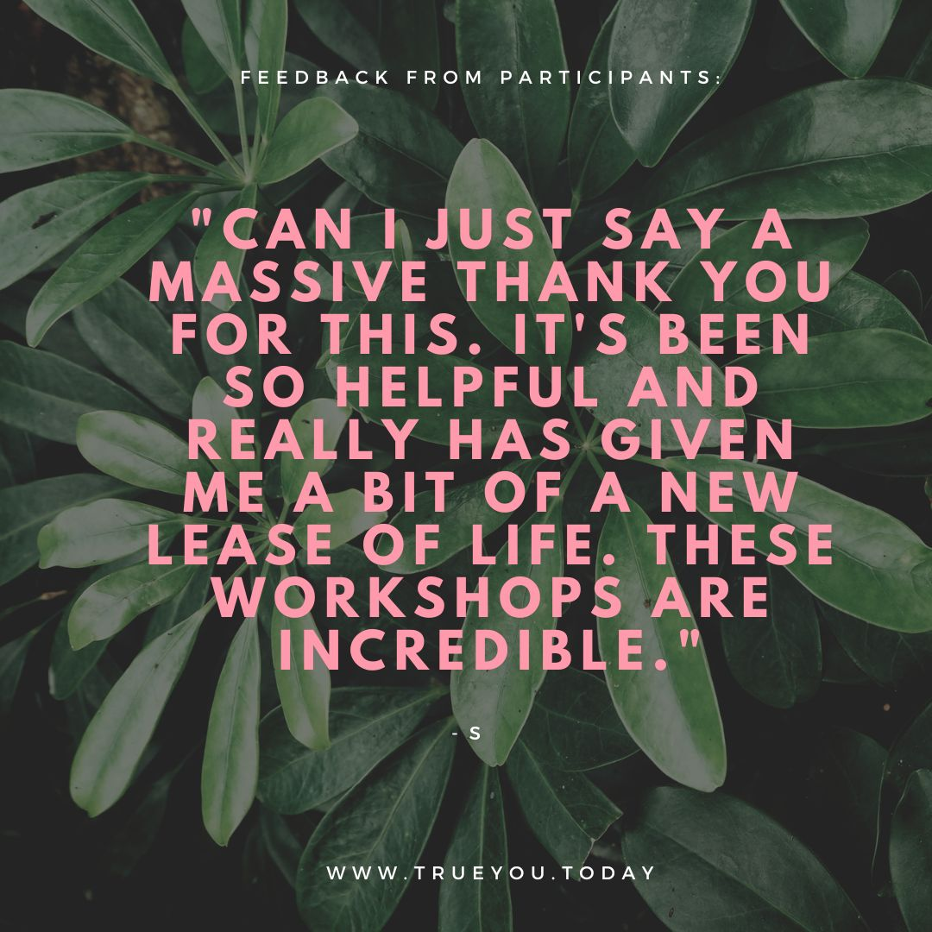
Your application may be chosen to be uploaded to the “best practise” page of the Self Care Forum website to share self-care excellence so that others might use the learnings in your application. We will also include your email address so that people may get in touch with you. If you would prefer that your application and/or email address was NOT chosen, then please make it clear in the box provided below.
Thank you for taking the time to apply for the Self-Care Awards. We look forward to receiving your application. Please email your completed form to: selfcare@selfcareforum.org

About the Self Care Forum
The Self Care Forum supports organisations in helping their communities and service users better understand how to self-care. It is the leading independent provider of best practice around self-care and the ‘go-to’ place for top quality resources, current opinion, and self-care interventions in the UK.
It is a charity and aims to improve public health by promoting self-care at national policy level. It creates free resources including self-care fact sheets, runs the UK-wide National Self-Care Week, and supports robust research evidence.

For more information about the Self Care Forum please go to the website. www.selfcareforum.org. Please find and follow us on LinkedIn, X and FB and Instagram.

